TEST 6
LISTENING

PART 1 Questions 1–10
Complete the notes below.
Write ONE WORD AND/OR A NUMBER for each answer.
TOTAL HEALTH CLINIC
PATIENT DETAILS
Personal information
Example
Garcia
Name Julie Anne ..............................
Contact phone  Date of birth  Occupation  Insurance company | 1 ..............................  2 .............................. , 1992  work as a 3 ..............................  4 .............................. Life Insurance
Detail of the problem  Type of problem  When it began  Action already taken | pain in her left 5 ..............................  6 .............................. ago  has taken painkillers and applied ice
Other information  Sports played  Medical history | belongs to a 7 .............................. club  goes 8 .............................. regularly  injured her 9 .............................. last year  no allergies  no regular medication apart from 10 ..............................

PART 2 Questions 11-20

Questions 11-14
Choose the correct letter, A, B or C.

Minster Park
11 The park was originally established
A as an amenity provided by the city council.
B as land belonging to a private house.
C as a shared area set up by the local community.
12 Why is there a statue of Diane Gosforth in the park?
A She was a resident who helped to lead a campaign.
B She was a council member responsible for giving the public access.
C She was a senior worker at the park for many years.
13 During the First World War, the park was mainly used for
A exercises by troops.
B growing vegetables.
C public meetings.
14 When did the physical transformation of the park begin?
A 2013
B 2015
C 2016

Questions 15-20
Label the map below.
Write the correct letter, A-l, next to Questions 15-20.

Minster Park

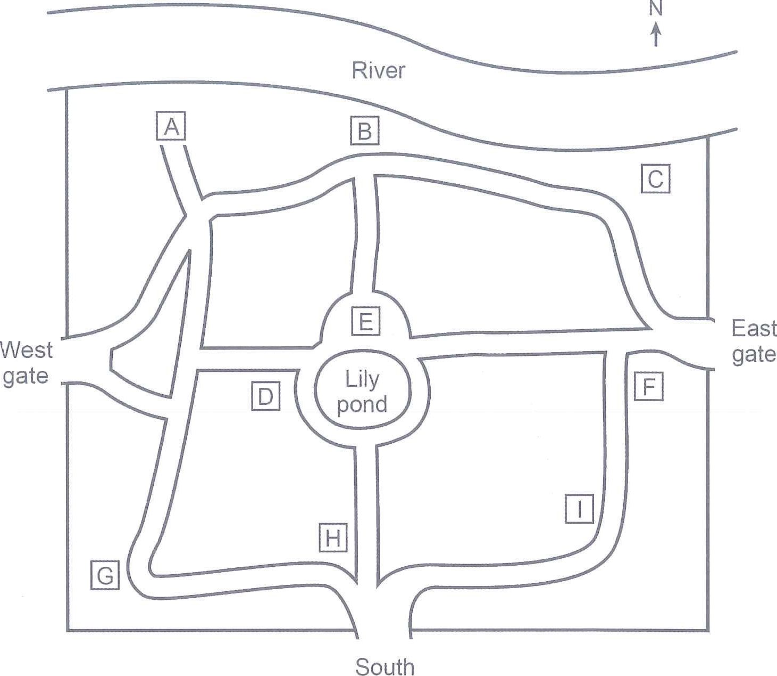
gate

15 statue of Diane Gosforth ………...
16 wooden sculptures
17 playground
18 maze ………...
19 tennis courts ………...
20 fitness area …………

PART 3 Questions 21-30
Questions 21-24
Choose the correct letter, A, B or C.

Assignment on sleep and dreams
21 Luke read that one reason why we often forget dreams is that
A our memories cannot cope with too much information.
B we might otherwise be confused about what is real.
C we do not think they are important.
22 What do Luke and Susie agree about dreams predicting the future?
A It may just be due to chance.
B It only happens with certain types of event.
C It happens more often than some people think.
23 Susie says that a study on pre-school children having a short nap in the day
A had controversial results.
B used faulty research methodology.
C failed to reach any clear conclusions.
24 In their last assignment, both students had problems with
A statistical analysis.
B making an action plan.
C self-assessment.

Questions 25-30
Complete the flow chart below.
Write ONE WORD ONLY for each answer.

Assignment plan
Decide on research question:
Is there a relationship between hours of sleep and number of dreams?
Decide on sample:
Twelve students from the 25 ……………….. department
Decide on methodology:
Self-reporting
Decide on procedure:
Answers on 26 ………………………….
Check ethical guidelines for working with 27 …………………………..
Ensure that risk is assessed and 28 ……………….. is kept to a minimum
Analyse the results
Calculate the correlation and make a 29 ……………………………..
30 ……………………………… the research

PART 4

Questions 31 – 40
Complete the notes below.
Write ONE WORD AND/OR A NUMBER for each answer.

The impact of digital technology on the Icelandic language
The Icelandic language
has approximately 31 …………………… speakers
has a 32 …………………… that is still growing
has not changed a lot over the last thousand years
has its own words for computer-based concepts, such as web browser and 33 ……………………
Young speakers
are big users of digital technology, such as 34 ……………………
are becoming 35 …………………… very quickly
are having discussions using only English while they are in the 36 …………………… at school
are better able to identify the content of a 37 …………………… in English than Icelandic
Technology and internet companies
write very little in Icelandic because of the small number of speakers and because of how complicated its 38 …………………… is
The Icelandic government
has set up a fund to support the production of more digital content in the language
believes that Icelandic has a secure future
is worried that young Icelanders may lose their 39 …………………… as Icelanders
is worried about the consequences of children not being 40 …………………… in either Icelandic or English

READING PASSAGE 1
You should spend about 20 minutes on Questions 1–13, which are based on Reading Passage 1 below.
Alexander Henderson (1831–1913)
Born in Scotland, Henderson emigrated to Canada in 1855 and became a well-known landscape photographer
Alexander Henderson was born in Scotland in 1831 and was the son of a successful merchant. His grandfather, also called Alexander, had founded the family business, and later became the first chairman of the National Bank of Scotland. The family had extensive landholdings in Scotland. Besides its residence in Edinburgh, it owned Press Estate, 650 acres of farmland about 35 miles southeast of the city. The family often stayed at Press Castle, the large mansion on the northern edge of the property, and Alexander spent much of his childhood in the area, playing on the beach near Eyemouth or fishing in the streams nearby.
Even after he went to school at Murcheston Academy on the outskirts of Edinburgh, Henderson returned to Press at weekends. In 1849 he began a three-year apprenticeship to become an accountant. Although he never liked the prospect of a business career, he stayed with it to please his family. In October 1855, however, he emigrated to Canada with his wife Agnes Elder Robertson and they settled in Montreal.
Henderson learned photography in Montreal around the year 1857 and quickly took it up as a serious amateur. He became a personal friend and colleague of the Scottish-Canadian photographer William Notman. The two men made a photographic excursion to Niagara Falls in 1860 and they cooperated on experiments with magnesium flares as a source of artificial light in 1865. They belonged to the same societies and were among the founding members of the Art Association of Montreal. Henderson acted as chairman of the association's first meeting, which was held in Notman's studio on 11 January 1860.
In spite of their friendship, their styles of photography were quite different. While Notman's landscapes were noted for their bold realism, Henderson for the first 20 years of his career produced romantic images, showing the strong influence of the British landscape tradition. His artistic and technical progress was rapid and in 1865 he published his first major collection of landscape photographs. The publication had limited circulation (only seven copies have ever been found), and was called Canadian Views and Studies. The contents of each copy vary significantly and have proved a useful source for evaluating Henderson's early work.
In 1866, he gave up his business to open a photographic studio, advertising himself as a portrait and landscape photographer. From about 1870 he dropped portraiture to specialize in landscape photography and other views. His numerous photographs of city life revealed in street scenes, houses, and markets are alive with human activity, and although his favourite subject was landscape he usually composed his scenes around such human pursuits as farming the land, cutting ice on a river, or sailing down a woodland stream. There was sufficient demand for these types of scenes and others he took depicting the lumber trade, steamboats and waterfalls to enable him to make a living. There was little competing hobby or amateur photography before the late 1880s because of the time-consuming techniques involved and the weight of the equipment. People wanted to buy photographs as souvenirs of a trip or as gifts, and catering to this market, Henderson had stock photographs on display at his studio for mounting, framing, or inclusion in albums.
Henderson frequently exhibited his photographs in Montreal and abroad, in London, Edinburgh, Dublin, Paris, New York, and Philadelphia. He met with greater success in 1877 and 1878 in New York when he won first prizes in the exhibition held by E and HT Anthony and Company for landscapes using the Lambertype process. In 1878 his work won second prize at the world exhibition in Paris.
In the 1870s and 1880s Henderson travelled widely throughout Quebec and Ontario, in Canada, documenting the major cities of the two provinces and many of the villages in Quebec. He was especially fond of the wilderness and often travelled by canoe on the Blanche, du Lièvre, and other noted eastern rivers. He went on several occasions to the Maritimes and in 1872 he sailed by yacht along the lower north shore of the St Lawrence River. That same year, while in the lower St Lawrence River region, he took some photographs of the construction of the Intercolonial Railway. This undertaking led in 1875 to a commission from the railway to record the principal structures along the almost-completed line connecting Montreal to Halifax. Commissions from other railways followed. In 1876 he photographed bridges on the Quebec, Montreal, Ottawa and Occidental Railway between Montreal and Ottawa. In 1885 he went west along the Canadian Pacific Railway (CPR) as far as Rogers Pass in British Columbia, where he took photographs of the mountains and the progress of construction.
In 1892 Henderson accepted a full-time position with the CPR as manager of a photographic department which he was to set up and administer. His duties included spending four months in the field each year. That summer he made his second trip west, photographing extensively along the railway line as far as Victoria. He continued in this post until 1897, when he retired completely from photography.
When Henderson died in 1913, his huge collection of glass negatives was stored in the basement of his house. Today collections of his work are held at the National Archives of Canada, Ottawa, and the McCord Museum of Canadian History, Montreal.

Questions 1–8
Do the following statements agree with the information given in Reading Passage 1?
In boxes 1–8 on your answer sheet, write
TRUE | if the statement agrees with the information
FALSE | if the statement contradicts the information
NOT GIVEN | if there is no information on this

1 | Henderson rarely visited the area around Press estate when he was younger.
2 | Henderson pursued a business career because it was what his family wanted.
3 | Henderson and Notman were surprised by the results of their 1865 experiment.
4 | There were many similarities between Henderson's early landscapes and those of Notman.
5 | The studio that Henderson opened in 1866 was close to his home.
6 | Henderson gave up portraiture so that he could focus on taking photographs of scenery.
7 | When Henderson began work for the Intercolonial Railway, the Montreal to Halifax line had been finished.
8 | Henderson's last work as a photographer was with the Canadian Pacific Railway.

Questions 9–13
Complete the notes below.
Choose ONE WORD ONLY from the passage for each answer.
Write your answers in boxes 9–13 on your answer sheet.
Alexander Henderson
Early life
- was born in Scotland in 1831 - father was a 9 ..............................
- trained as an accountant, emigrated to Canada in 1855
Start of a photographic career
- opened up a photographic studio in 1866
- took photos of city life, but preferred landscape photography
- people bought Henderson's photos because photography took up considerable time and the 10 .............................. was heavy
- the photographs Henderson sold were 11 .............................. or souvenirs
Travelling as a professional photographer
- travelled widely in Quebec and Ontario in 1870s and 1880s
- took many trips along eastern rivers in a 12 ..............................
- worked for Canadian railways between 1875 and 1897
- worked for CPR in 1885 and photographed the 13 .............................. and the railway at Rogers Pass

READING PASSAGE 2
You should spend about 20 minutes on Questions 14-26, which are based on Reading Passage 2 below.

Should we try to bring extinct species back to life?
A The passenger pigeon was a legendary species. Flying in vast numbers across North America, with potentially many millions within a single flock, their migration was once one of nature’s great spectacles. Sadly, the passenger pigeon’s existence came to an end on 1 September 1914, when the last living specimen died at Cincinnati Zoo. Geneticist Ben Novak is lead researcher on an ambitious project which now aims to bring the bird back to life through a process known as ‘deextinction’. The basic premise involves using cloning technology to turn the DNAof extinct animals into a fertilised embryo, which is carried by the nearest relative still in existence - in this case, the abundant band-tailed pigeon - before being born as a living, breathing animal. Passenger pigeons are one of the pioneering species in this field, but they are far from the only ones on which this cutting-edge technology is being trialled.
B In Australia, the thylacine, more commonly known as the Tasmanian tiger, is another extinct creature which genetic scientists are striving to bring back to life. ‘There is no carnivore now in Tasmania that fills the niche which thylacines once occupied,’ explains Michael Archer of the University of New South Wales. He points out that in the decades since the thylacine went extinct, there has been a spread in a ‘dangerously debilitating’ facial tumour syndrome which threatens the existence of the Tasmanian devils, the island’s other notorious resident. Thylacines would have prevented this spread because they would have killed significant numbers of Tasmanian devils. ‘If that contagious cancer had popped up previously, it would have burned out in whatever region it started. The return of thylacines to Tasmania could help to ensure that devils are never again subjected to risks of this kind.’
C If extinct species can be brought back to life, can humanity begin to correct the damage it has caused to the natural world over the past few millennia? ‘The idea of de-extinction is that we can reverse this process, bringing species that no longer exist back to life,’ says Beth Shapiro of University of California Santa Cruz’s Genomics Institute. ‘I don’t think that we can do this. There is no way to bring back something that is 100 per cent identical to a species that went extinct a long time ago.’ A more practical approach for long-extinct species is to take the DNA of existing species as a template, ready for the insertion of strands of extinct animal DNA to create something new; a hybrid, based on the living species, but which looks and/or acts like the animal which died out.
D This complicated process and questionable outcome begs the question: what is the actual point of this technology? ‘For us, the goal has always been replacing the extinct species with a suitable replacement,’ explains Novak. ‘When it comes to breeding, band-tailed pigeons scatter and make maybe one or two nests per hectare, whereas passenger pigeons were very social and would make 10,000 or more nests in one hectare.’ Since the disappearance of this key species, ecosystems in the eastern US have suffered, as the lack of disturbance caused by thousands of passenger pigeons wrecking trees and branches means there has been minimal need for regrowth. This has left forests stagnant and therefore unwelcoming to the plants and animals which evolved to help regenerate the forest after a disturbance. According to Novak, a hybridised band-tailed pigeon, with the added nesting habits of a passenger pigeon, could, in theory, re-establish that forest disturbance, thereby creating a habitat necessary for a great many other native species to thrive.
E Another popular candidate for this technology is the woolly mammoth. George Church, professor at Harvard Medical School and leader of the Woolly Mammoth Revival Project, has been focusing on cold resistance, the main way in which the extinct woolly mammoth and its nearest living relative, the Asian elephant, differ. By pinpointing which genetic traits made it possible for mammoths to survive the icy climate of the tundra, the project’s goal is to return mammoths, or a mammothlike species, to the area. ‘My highest priority would be preserving the endangered Asian elephant,’ says Church, ‘expanding their range to the huge ecosystem of the tundra. Necessary adaptations would include smaller ears, thicker hair, and extra insulating fat, all for the purpose of reducing heat loss in the tundra, and all traits found in the now extinct woolly mammoth.’ This repopulation of the tundra and boreal forests of Eurasia and North America with large mammals could also be a useful factor in reducing carbon emissions - elephants punch holes through snow and knock down trees, which encourages grass growth. This grass growth would reduce temperatures, and mitigate emissions from melting permafrost.
F While the prospect of bringing extinct animals back to life might capture imaginations, it is, of course, far easier to try to save an existing species which is merely threatened with extinction. ‘Many of the technologies that people have in mind when they think about de-extinction can be used as a form of “genetic rescue”,’ explains Shapiro. She prefers to focus the debate on how this emerging technology could be used to fully understand why various species went extinct in the first place, and therefore how we could use it to make genetic modifications which could prevent mass extinctions in the future. ‘I would also say there’s an incredible moral hazard to not do anything at all,’ she continues. ‘We know that what we are doing today is not enough, and we have to be willing to take some calculated and measured risks.’

Questions 14-17
Reading Passage 2 has six paragraphs, A-F.
Which paragraph contains the following information?

Write the correct letter, A-F, in boxes 14-17 on your answer sheet.
NB You may use any letter more than once.

14 a reference to how further disappearance of multiple species could be avoided
15 explanation of a way of reproducing an extinct animal using the DNA of only that species
16 reference to a habitat which has suffered following the extinction of a species
17 mention of the exact point at which a particular species became extinct

Questions 18-22
Complete the summary below.
Choose NO MORE THAN TWO WORDS from the passage for each answer.
Write your answers in boxes 18-22 on your answer sheet.

The woolly mammoth revival project
Professor George Church and his team are trying to identify the 18………………………which enabled mammoths to live in the tundra. The findings could help preserve the mammoth’s close relative, the endangered Asian elephant.
According to Church, introducing Asian elephants to the tundra would involve certain physical adaptations to minimise 19……………………… To survive in the tundra, the species would need to have the mammoth-like features of thicker hair, 20……………………… of a reduced size and more 21………………………
Repopulating the tundra with mammoths or Asian elephant/mammoth hybrids would also have an impact on the environment, which could help to reduce temperatures and decrease 22………………………

Questions 23-26
Look at the following statements (Questions 23-26) and the list of people below.
Match each statement with the correct person, A, B or C.

Write the correct letter, A, B or C, in boxes 23-26 on your answer sheet.
NB You may use any letter more than once.

23 Reintroducing an extinct species to its original habitat could improve the health of a particular species living there.
24 It is important to concentrate on the causes of an animal’s extinction.
25 A species brought back from extinction could have an important beneficial impact on the vegetation of its habitat.
26 Our current efforts at preserving biodiversity are insufficient.

List of People
A Ben Novak
B Michael Archer
C Beth Shapiro

READING PASSAGE 3
You should spend about 20 minutes on Questions 27-40, which are based on Reading Passage 3 below.

How to make wise decisions
Across cultures, wisdom has been considered one of the most revered human qualities. Although the truly wise may seem few and far between, empirical research examining wisdom suggests that it isn’t an exceptional trait possessed by a small handful of bearded philosophers after all - in fact, the latest studies suggest that most of us have the ability to make wise decisions, given the right context.

‘It appears that experiential, situational, and cultural factors are even more powerful in shaping wisdom than previously imagined,’ says Associate Professor Igor Grossmann of the University of Waterloo in Ontario, Canada. ‘Recent empirical findings from cognitive, developmental, social, and personality psychology cumulatively suggest that people’s ability to reason wisely varies dramatically across experiential and situational contexts. Understanding the role of such contextual factors offers unique insights into understanding wisdom in daily life, as well as how it can be enhanced and taught.’

It seems that it’s not so much that some people simply possess wisdom and others lack it, but that our ability to reason wisely depends on a variety of external factors. ‘It is impossible to characterize thought processes attributed to wisdom without considering the role of contextual factors,’ explains Grossmann. ‘In other words, wisdom is not solely an “inner quality” but rather unfolds as a function of situations people happen to be in. Some situations are more likely to promote wisdom than others.’

Coming up with a definition of wisdom is challenging, but Grossmann and his colleagues have identified four key characteristics as part of a framework of wise reasoning. One is intellectual humility or recognition of the limits of our own knowledge, and another is appreciation of perspectives wider than the issue at hand. Sensitivity to the possibility of change in social relations is also key, along with compromise or integration of different attitudes and beliefs.

Grossmann and his colleagues have also found that one of the most reliable ways to support wisdom in our own day-to-day decisions is to look at scenarios from a third-party perspective, as though giving advice to a friend. Research suggests that when adopting a first-person viewpoint we focus on ‘the focal features of the environment’ and when we adopt a third-person, ‘observer’ viewpoint we reason more broadly and focus more on interpersonal and moral ideals such as justice and impartiality. Looking at problems from this more expansive viewpoint appears to foster cognitive processes related to wise decisions.

What are we to do, then, when confronted with situations like a disagreement with a spouse or negotiating a contract at work, that require us to take a personal stake? Grossmann argues that even when we aren’t able to change the situation, we can still evaluate these experiences from different perspectives.

For example, in one experiment that took place during the peak of a recent economic recession, graduating college seniors were asked to reflect on their job prospects. The students were instructed to imagine their career either ‘as if you were a distant observer’ or ‘before your own eyes as if you were right there’. Participants in the group assigned to the ‘distant observer’ role displayed more wisdom-related reasoning (intellectual humility and recognition of change) than did participants in the control group.

In another study, couples in long-term romantic relationships were instructed to visualize an unresolved relationship conflict either through the eyes of an outsider or from their own perspective. Participants then discussed the incident with their partner for 10 minutes, after which they wrote down their thoughts about it. Couples in the ‘other’s eyes’ condition were significantly more likely to rely on wise reasoning - recognizing others’ perspectives and searching for a compromise - compared to the couples in the egocentric condition.

‘Ego-decentering promotes greater focus on others and enables a bigger picture, conceptual view of the experience, affording recognition of intellectual humility and change,’ says Grossmann.

We might associate wisdom with intelligence or particular personality traits, but research shows only a small positive relationship between wise thinking and crystallized intelligence and the personality traits of openness and agreeableness. ‘It is remarkable how much people can vary in their wisdom from one situation to the next, and how much stronger such contextual effects are for understanding the relationship between wise judgment and its social and affective outcomes as compared to the generalized “traits”,’ Grossmann explains. ‘That is, knowing how wisely a person behaves in a given situation is more informative for understanding their emotions or likelihood to forgive [or] retaliate as compared to knowing whether the person may be wise “in general”.’

Questions 27-30
Choose the correct letter, A, B, C or D.
Write the correct letter in boxes 27-30 on your answer sheet.

27 What point does the writer make in the first paragraph?
A Wisdom appears to be unique to the human race.
B A basic assumption about wisdom may be wrong.
C Concepts of wisdom may depend on the society we belong to.
D There is still much to be discovered about the nature of wisdom.

28 What does Igor Grossmann suggest about the ability to make wise decisions?
A It can vary greatly from one person to another.
B Earlier research into it was based on unreliable data.
C The importance of certain influences on it was underestimated.
D Various branches of psychology define it according to their own criteria.

29 According to the third paragraph, Grossmann claims that the level of wisdom an individual shows
A can be greater than they think it is.
B will be different in different circumstances.
C may be determined by particular aspects of their personality.
D should develop over time as a result of their life experiences.

30 What is described in the fifth paragraph?
A a difficulty encountered when attempting to reason wisely
B an example of the type of person who is likely to reason wisely
C a controversial view about the benefits of reasoning wisely
D a recommended strategy that can help people to reason wisely

Questions 31-35
Complete the summary using the list of words, A-J, below.
Write the correct letter, A-J, in boxes 31-35 on your answer sheet.

The characteristics of wise reasoning
Igor Grossmann and colleagues have established four characteristics which enable us to make wise decisions. It is important to have a certain degree of 31 regarding the extent of our knowledge, and to take into account 32 which may not be the same as our own. We should also be able to take a broad 33 of any situation. Another key characteristic is being aware of the likelihood of alterations in the way that people relate to each other.
Grossmann also believes that it is better to regard scenarios with 34 By avoiding the first-person perspective, we focus more on 35 and on
other moral ideals, which in turn leads to wiser decision-making.

A | opinions | B | confidence | C | view
D | modesty | E | problems | F | objectivity
G | fairness | H | experiences | I | range
J | reasons

Questions 36-40
Do the following statements agree with the information given in Reading Passage 3?
In boxes 36-40 on your answer sheet, write
TRUE if the statement agrees with the information
FALSE if the statement contradicts the information
NOT GIVEN if there is no information on this

36 Students participating in the job prospects experiment could choose one of two perspectives to take.
37 Participants in the couples experiment were aware that they were taking part in a study about wise reasoning.
38 In the couples experiments, the length of the couples’ relationships had an impact on the results.
39 In both experiments, the participants who looked at the situation from a more detached viewpoint tended to make wiser decisions.
40 Grossmann believes that a person’s wisdom is determined by their intelligence to only a very limited extent.

WRITING TASK 1
You should spend about 20 minutes on this task.
The chart below shows the value of one country’s exports in various categories during 2015 and 2016. The table shows the percentage change in each category of exports in 2016 compared with 2015.
Summarise the information by selecting and reporting the main features, and make comparisons where relevant.

Write at least 150 words.
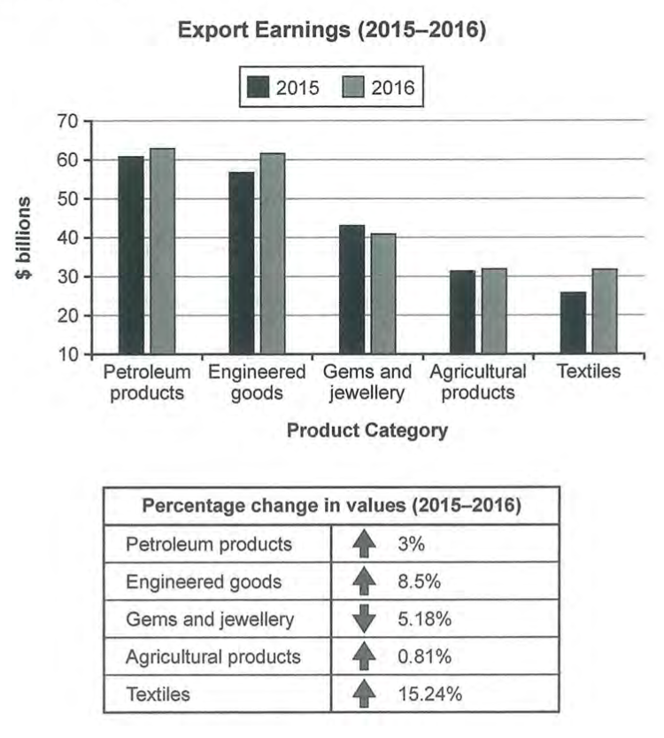

WRITING TASK 2
You should spend about 40 minutes on this task.
Write about the following topic:

In the future, nobody will buy printed newspapers or books because they will be able to read everything they want online without paying.
To what extent do you agree or disagree with this statement?

Give reasons for your answer and include any relevant examples from your own knowledge or experience.
Write at least 250 words.

PART 1
The examiner asks you about yourself, your home, work or studies and other familiar topics.
EXAMPLE
Social Media
- Which social media websites do you use?
- How much time do you spend on social media sites? [Why/Why not?]
- What kind of information about yourself have you put on social media? [Why/Why not?]
- Is there anything you don't like about social media? [Why?]

PART 2
Describe a website that you bought something from. You should say:  what the website is  what you bought from this website h  how satisfied you were with what you bought  and explain what you liked or disliked about using this website. | You will have to talk about the topic for one to two minutes. You have one minute to think about what you are going to say. You can make some notes to help you if you wish.

PART 3
Discussion topics:
Shopping online
Example questions:

What kinds of things do people in your country often buy from online shops?
Why do you think online shopping has become so popular nowadays?
What are some possible disadvantages of buying things from online shops?

The culture of consumerism
Example questions:
Why do many people today keep buying things which they do not need?
Do you believe the benefits of a consumer society outweigh the disadvantages? How possible is it to avoid the culture of consumerism?

